18 April PTO Meeting- Minutes

- Meeting Called To Order at _5:37
- Introductions
  - _______________- President
  - Ricardo Gutierrez - Vice President
  - Julie Little - Secretary
  - _______________- Treasurer
- Secretary Minutes Report
  - The March 21st PTO Meeting was called to order at 5:35 and adjourned at 6:30. - Shared minutes and highlights of the March PTO Meeting.
- Public Comment
  - Build-A-Cougar At Igo
    - Preorder 4/8 - 4/20
    - Build-A-Cougar Day 4/2; Kit pick up on 5/9
- Announcements
  - We have a Double Creek Elementary School PTO Facebook Page; Join us!
    - Membership Questions - Members agreed to the questions posted; membership will be declined if questions not answered and/or rules not agreed to
      - Do you have a student at DCES?
      - What is your student's name?
      - Who is your student's teacher?
      - Select to agree to rules
- Treasurer’s Report -Adjusted placement in agenda due to votes concerning expenses to the PTO.
  - Treasurer update - Shared copies of the treasurer report and went over specifics.
- Principal’s Update
  - Principal Update
    - PTO Today Renewal for $149.
    - Vote- Motion for PTO Today Renewal. 2nd motion. Vote: Ayes have it
- Secretary’s Report
  - Change Drive Update
    - 83 lbs and 1 oz of change was donated!
    - Amount deposited in our PTO account: $548.51
    - Popsicles were donated by our wonderful Tammy Stallings and provided to winning classes 4/12.
  - BOOSTER Fundraiser Update -
    - Contract signed and deposit of $500 paid; remaining $500 will come out of profit
    - Students voted on the Glow Dance; Name the event: Cougar Caper, Cougar hop, etc - Asked for other suggestions; none given. Motion to use ‘Cougar Caper’ as Event Name. 2nd motion. Vote: Ayes have it
    - Coordinator suggested a goal of $7,000, as this is typical for a new school - If monetary goal is met Dr. Wilson will participate in a Lip Sync Battle (Who will he VS?). If 50% registration is reached, Dr. Wilson will shave his head.
    - Kick off is May13th and Event/Dance is May 22nd during specials - This is also the same day (5/22) as Kinder graduation. We need to figure out this schedule ASAP
    - Will parents be invited or volunteers only? - We think that it would create a safety issue.
    - Discuss decor ideas and vote on budget for supplies; 2 spirit sticks need to be created- Discussed a reasonable amount to use for supplies. Motion to utilize a budget of no more than $500 for glow dance supplies. 2nd motion. Ayes have it.
      - Walker will reach out about some glow day supplies to borrow. We will order any supplies after hearing back.
      - Ask Coach about using the neon scarves for dancers.
      - Use exterior entrance/exits
      - Any lights need to project on a wide area
      - Idea to get christmas lights (laser christmas lights; the ones that shine on houses)
      - Make sure to look at reviews when looking for blacklights.
    - VOLUNTEERS: set up (5/21 after school) and tear down (5/22 after event)- Rebel, Rebekah Huntley, Welle, and Lake will help out. Collaborate with Little closer to the date..
    - Next Year: Do earlier in the fall/winter?- Next year do it earlier in the fall so we don't possibly lose 5th grade support due to them leaving the campus. We will try to reuse items for future glow events.

- Committee Reports
  - None
- New Business
  - Spring Elections coming up -
    - Ask for nominations:
      - Nomination of Rebel Sanders for Secretary by Little/Walker
      - Nomination of Ricardo Gutierrez for President by Little
      - Nomination of Rebekah Huntly for Vice President by Little/Walker

- Unfinished Business
  - None
- Member Questions/Comments
  - None
- Adjournment at _6:15__ Motion to adjourn.2nd motion. Vote: Ayes have it.


IDEAS:
FOR STUDENTS - 2 PER STUDENT TO KEEP?
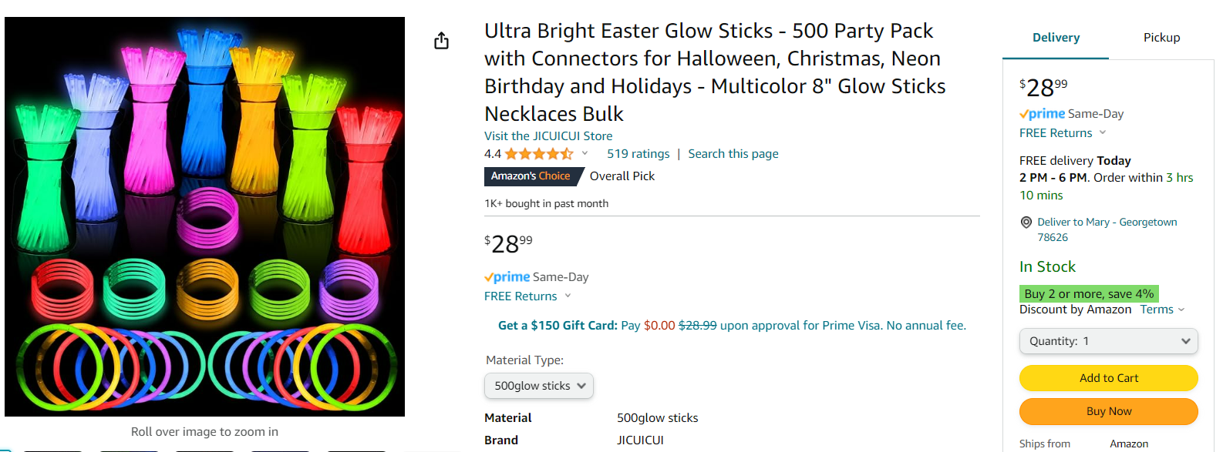
https://a.co/d/gRaYbUV


https://a.co/d/hnvmGnX

TO DECORATE/DANCE:

https://a.co/d/fLqlgep

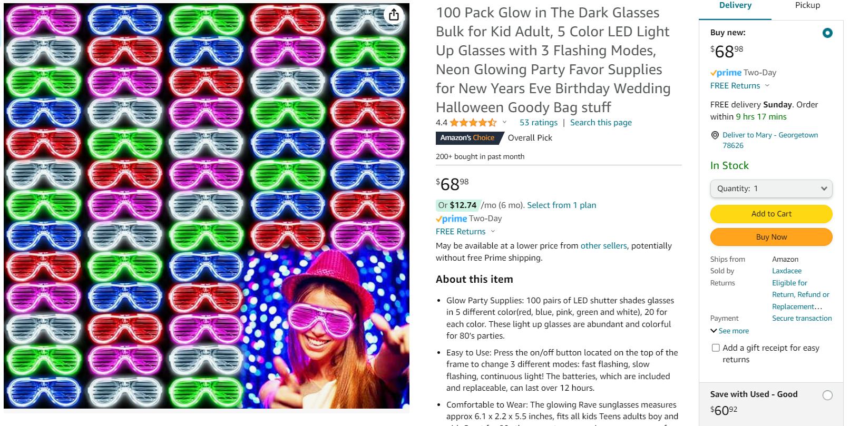
https://a.co/d/8UeLffU For student use; Students return as they are exiting the gym so the next grade level can use - OR we just let families know to dress up in glow gear that day -


https://a.co/d/hnZleN0

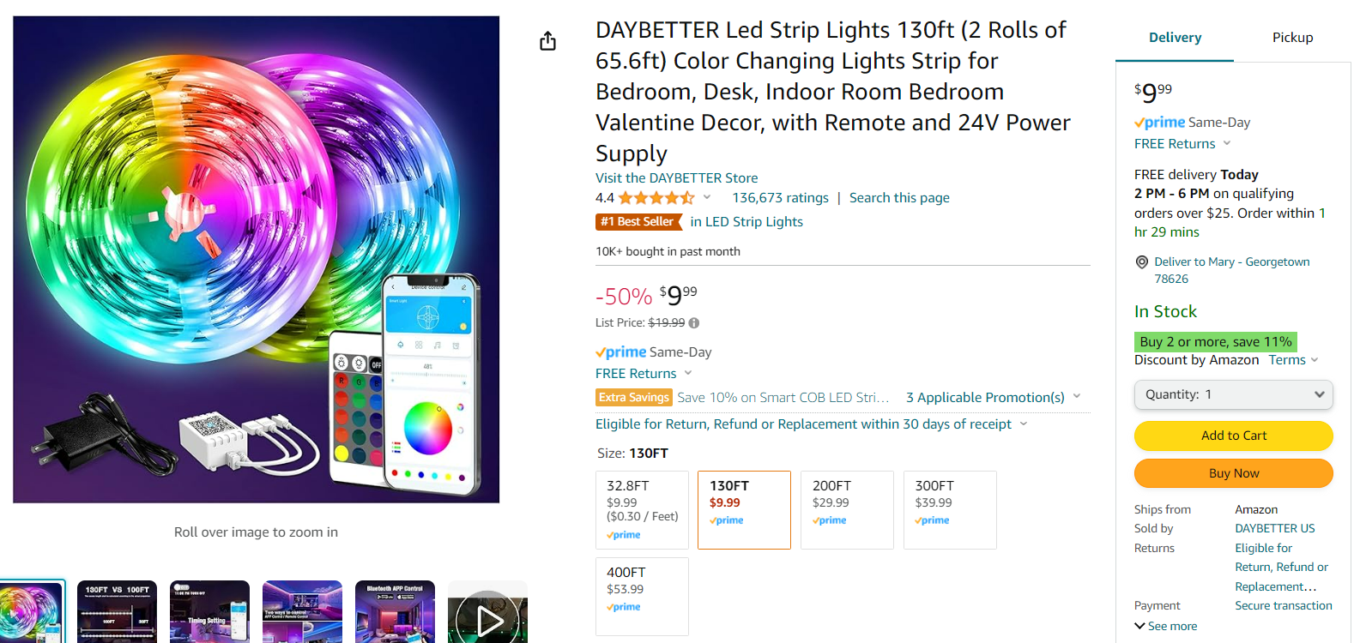
https://a.co/d/ddieajy
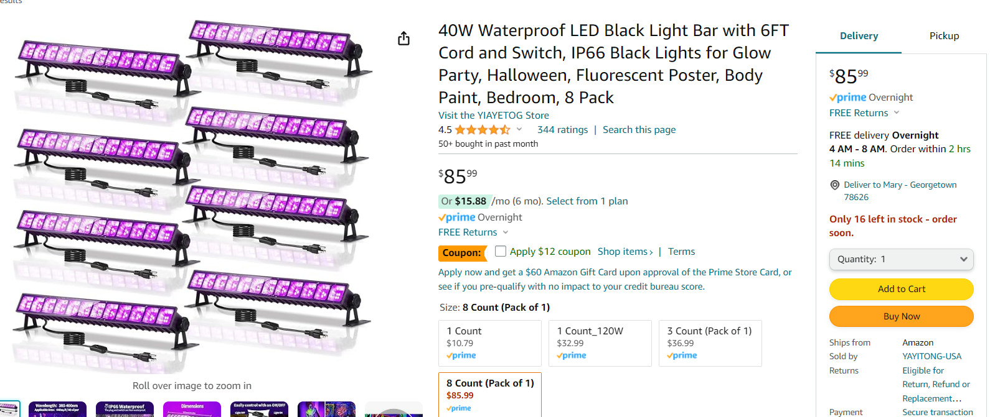
https://a.co/d/hAUVMID

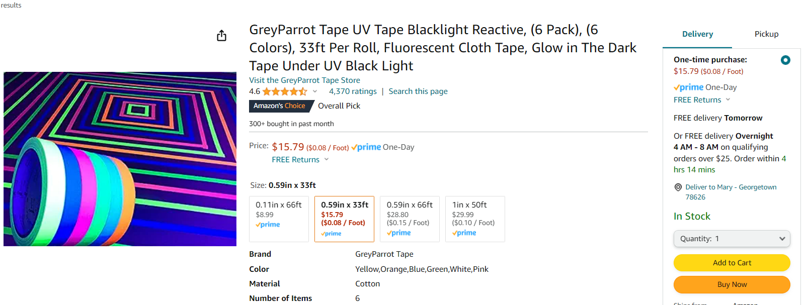
https://a.co/d/1D6TPQO

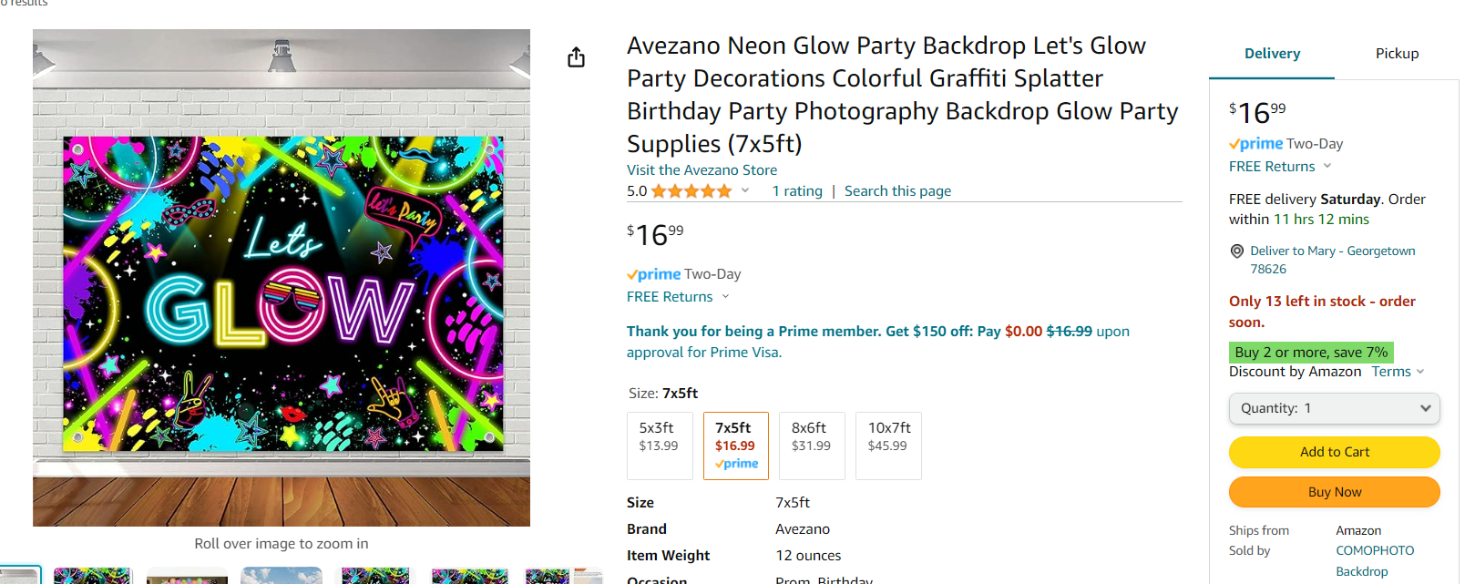
https://a.co/d/fmJbJdy


https://a.co/d/6fvxhGh


https://a.co/d/5vojIHp

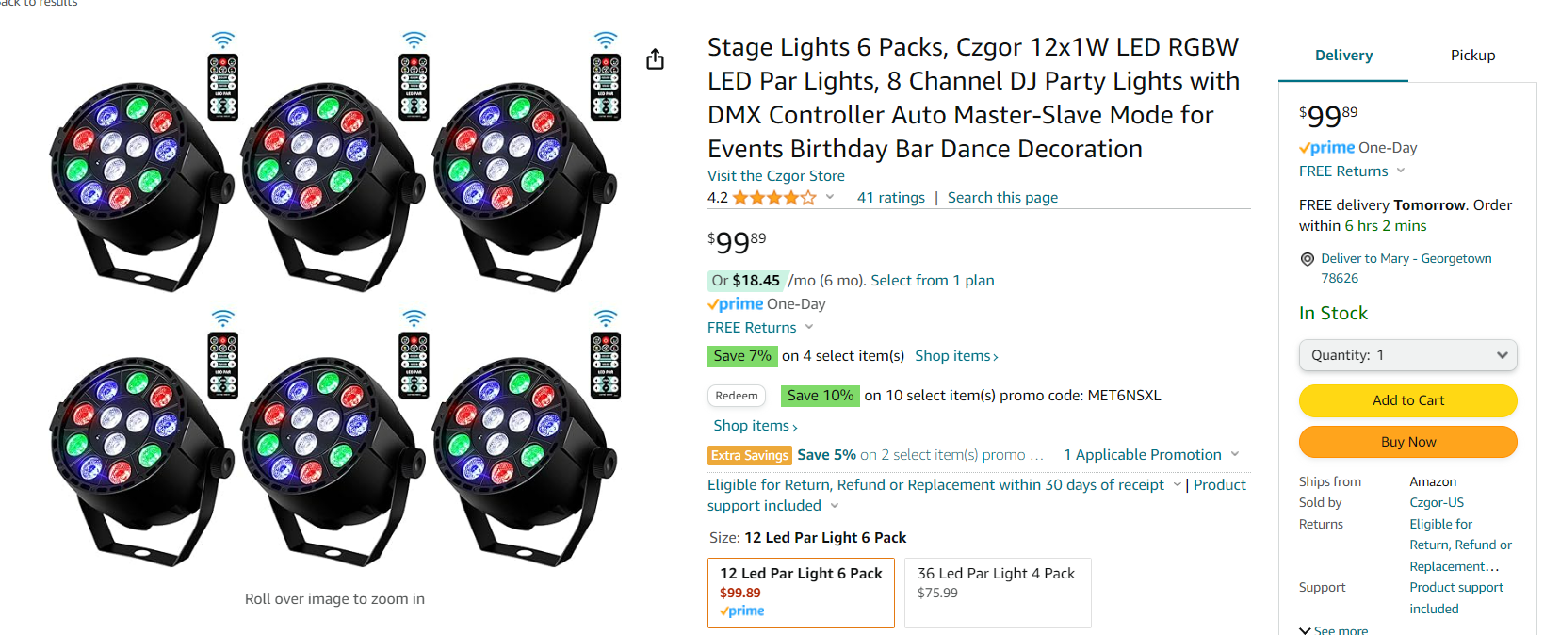https://a.co/d/6WBkyg6

